FEDERAL UNIVERSITY OF TECHNOLOGY, OWERRI

P.M.B 1526 IMO STATE

GIS-BASED ANALYSIS OF SOLAR ENERGY POTENTIAL IN FUTO

BY
AGHARANDU MICHEAL O. 20212298413
NKWODINMA KELVIN-PAUL M. 20201226073
NWAOGU SAMUEL C. 20201202553
ONWUBIKO GODSWILL C. 20201203373
OSAKWE BONAVENTURE I. 20192184823

A PROJECT REPORT SUBMITTED TO THE

DEPARTMENT OF ELECTRICAL AND ELECTRONICS ENGINEERING

SCHOOL OF ELECTRICAL SYSTEMS ENGINEERING AND TECHNOLOGY

IN PARTIAL FULFILMENT OF THE REQUIREMENTS FOR THE AWARD OF THE BACHELORS OF ENGINEERING DEGREE (B. Eng.) IN ELECTRICAL AND ELECTRONICS ENGINEERING

OCTOBER 2025

CERTIFICATION
This is to certify that this project work titled, “GIS-BASED ANALYSIS OF SOLAR ENERGY POTENTIAL IN FUTO”, is an authentic work carried out by Agharandu Micheal O. (20212298413), Nkwodinma Kelvin-Paul M. (20201226073), Nwaogu Samuel C. (20201202553), Onwubiko Godswill C. (20201203373), and Osakwe Bonaventure I. (20192184823), in partial fulfilment of the requirements for the award of the Bachelor of Engineering (B.Eng.) degree in Electrical and Electronic Engineering, Federal University of Technology, Owerri.

Approved By:

___________________ ________
ENGR. C. OGOMAKA Date
Project Supervisor

___________________ ________
PROF. N. CHUKWUCHEKWA Date
Head Of Department

__________________ ________
PROF. D.O. DIKE Date
Dean, SESET

__________________ ________
EXTERNAL EXAMINER Date

DEDICATION
This Project work is dedicated to a set of important personalities in our life;

The Almighty GOD who has been right from the beginning to this very point. Our ever-loving Parents and Guardians,

And all those who helped us in one way or the other during this projects work, God be the Glory.

ACKNOWLEDGEMENT
First and foremost, our appreciation goes to the source that creates life for the gift of good health and knowledge.

This project is a testament to the persistent pursuit of knowledge, fueled by the unwavering love and support of our families and the valuable guidance of our mentors, and the synergy of our team. We extend our profound appreciation to our families; both nuclear and extended, for their enduring support. Our mentors have been beacons of enlightenment, shaping our academic journey.

We would like to express our profound appreciation to our supervisor Engr. C. Ogoamaka for his insightful guidance, mentorship, and assistance. Your expertise and willingness to share knowledge has been invaluable in shaping the direction of this Project Work.

In the same way, we extend our gratitude to the Head of Department, Engr. Dr. Nkwachukwu Chukwuchekwa, for his impact throughout the course of the work.

We sincerely acknowledge the impact of the knowledge from all our lecturers all through the course of our undergraduate pursuit in Power and System Engineering; notably, Engr..Prof. D. O. Dike, Engr. Dr. S.O. Okozi, Engr. E. O. Ezugwu, Engr. Dr. M. Olubiwe, Engr. Prof. E. N. C. Okafor, Engr. Dr. C. J. Joe-Uzoegbu, Engr. Prof. O. J. Onojo, Engr. Dr. I. O. Akwukwaegbu, Engr. Dr. R. O. Opara and Engr. P. C. Ohiri.

All staff and management of Electrical and Electronics Engineering department are indeed appreciated for contributing their quota in making this project a success.

To our Parents, God bless you all for your support and encouragement from the day one of this project work.

Our friends and classmates have enriched this experience, their encouragement and companionship etching lasting memories. We appreciate each and every one.

We are also grateful to our friends and well-wishers for their patience,
encouragement, and understanding as I dedicated time to this Project work. Their unwavering belief in us kept us motivated and focused.

Lastly, we want to acknowledge the resources we utilized throughout this Project work, including academic literature, online references, and tools that aided in data analysis and visualization.

In conclusion, We are humbled by the support and encouragement we have received from various quarters. This project would not have been possible without the collective effort and contributions of all those mentioned and even those unmentioned. Thank you for being a part of this endeavor.

ABSTRACT
This study assesses the solar energy generation potential of the Federal University of Technology, Owerri (FUTO), using geospatial techniques. Key spatial datasets—including solar radiation, building footprints, roof surface areas, slope, aspect, and tree cover—were collected and integrated within a Geographic Information System (GIS). Solar radiation data were sourced from the NASA POWER database, building footprints from OpenStreetMap, and vegetation from satellite imagery. A Digital Elevation Model (DEM) was employed to extract slope and aspect parameters. These layers were standardized, reclassified, and combined through a Weighted Overlay Analysis to develop a Solar Energy Potential Index (SEPI). The adopted weights were solar radiation (35%), roof slope (20%), aspect (15%), roof area (15%), and tree cover/shading (15%). The SEPI results categorized FUTO rooftops into high, medium, and low potential zones. Rooftops with south/east orientation, slope angles ≤15°, and minimal shading exhibited the highest suitability for photovoltaic installation. The study demonstrates that integrating spatial and environmental factors provides an effective, replicable framework for solar energy assessment in institutional environments.

DEFINITION OF TERMS
- Geographic Information Systems (GIS): A computer-based system for capturing, storing, analyzing, and displaying spatial or geographic data.
- Solar Radiation: The electromagnetic energy from the sun received on Earth’s surface, measured in W/m².
- Photovoltaic: Technology that converts sunlight directly into electricity using semiconductor materials.
- Solar Energy: Energy derived from the sun’s radiation, usable for heating, electricity generation, and other applications.
- Solar Energy Potential Index: A composite index that evaluates the suitability of locations for solar energy generation based on spatial and environmental factors.
- Building orientation: The positioning of a building with respect to the sun’s path, which affects solar exposure.
- Roof area: The total surface area of a building’s roof available for installing solar panels.
- Slope: The angle of inclination of a surface (e.g., a roof) relative to the horizontal plane.
- Aspect: The compass direction that a slope or roof surface faces, such as north, south, east, or west.
- Tree cover: The presence and density of vegetation around buildings, which can provide shading and reduce available solar radiation.
- Spatial And Environmental Factors: Physical and geographical variables (e.g., slope, aspect, tree cover, roof orientation) that influence solar energy potential.
- Carbon Footprint: The total amount of greenhouse gases (mainly CO₂) emitted directly or indirectly by human activities.
- Renewable Energy Sources: Naturally replenishing energy resources such as solar, wind, hydro, geothermal, and biomass.

LIST OF SYMBOLS AND ABBREVIATIONS
- FUTO - Federal University of Technology
- GIS – Geographic Information System
- MCDA – Multi Criteria Decision Analysis
- SEPI – Solar Energy Potential Index
- DEM – Digital Elevation Model
- AHP – Analytic Hierarchy Process
- PV - Photovoltaics
- NASA - National Aeronautics and Space Administration
- NDVI – Normalized Difference Vegetation Index
- UTM - Universal Transverse Mercator
- WGS - World Geodetic System
- SRTM - Shuttle Radar Topography Mission
- GHI - Global Horizontal Irradiance
- DNI – Direct Normal Irradiance
- DHI - Diffuse Horizontal Irradiance
- GPS - Global Positioning System

LIST OF TABLES
Table 3.1: Criteria and Weights for SEPI Development

LIST OF FIGURES AND DIAGRAMS
Fig 1.1: Map of Nigeria Indicating the global solar radiation
Fig 2.1: World Solar Energy Map
Fig 4.1: A hybrid Basemap of FUTO obtained from ARCGIS

TABLE OF CONTENTS
Certification Page I
Dedication II
Acknowledgement III
Abstract V
Definition of Terms VI
List of Symbols and Abbreviations VIII
List of Tables IX
List of Figures and Diagrams X
Table of Contents XI

CHAPTER ONE: INTRODUCTION
  - Background of study 1
  - Problem Statement 3
  - Aims and Objectives 4
    - Main Objective 4
    - Specific Objectives 4
  - Significance of Study 5
  - Scope of study 6

CHAPTER TWO: LITERATURE REVIEW
2.1 Introduction 7
2.2 GIS in Solar Energy Potential Mapping 8
2.3 Multi Criteria and Advanced GIS Techniques 9
2.4 Solar Potential studies in Africa and Nigeria 10
2.5 Research Gaps and Relevance in FUTO 11
2.6 Conclusion 12

CHAPTER THREE: MATERIALS AND METHOD
3.1 Study Area 13
3,2 Materials 13
3.2.1 Software and Tools 13
3.2.2 Data Sources 13
3.3 Methodology 14
3.3.1 Data Collection and preparation 14
3.3.2 Environmental and spatial factors analysis 14
3.3.3 Solar Radiation Analysis 15
3.3.4 Solar Energy Potential Index (SEPI) Development 15
3.1.5 Thematic Map Generation 16
3.1.6 Validation and accuracy assessment 16
CHAPTER FOUR: RESULT AND DISCUSSIONS
CHAPTER FIVE: CONCLUSIONS AND RECOMMENDATIONS
REFERENCES

CHAPTER ONE
INTRODUCTION
  - BACKGROUND OF STUDY
With the global push for sustainable and renewable energy sources, solar energy has emerged as a leading alternative to conventional fossil fuels. The integration of Geographic Information Systems (GIS) in energy planning and analysis has revolutionized how researchers and planners evaluate solar energy potential. GIS-based solar energy analysis allows for precise spatial assessments, offering visual insights into where solar resources are most viable based on various environmental and infrastructural parameters. In the context of institutional energy demands and the rising cost of electricity in Nigeria, evaluating the solar potential of the Federal University of Technology, Owerri (FUTO) becomes not just timely but strategic. The university, with its large land area, numerous rooftops, and diverse landscape, presents an ideal case for applying GIS technology in renewable energy assessment. This research aims to identify optimal locations within FUTO for solar panel deployment, factoring in environmental variables and infrastructural data to support efficient and cost-effective energy solutions.
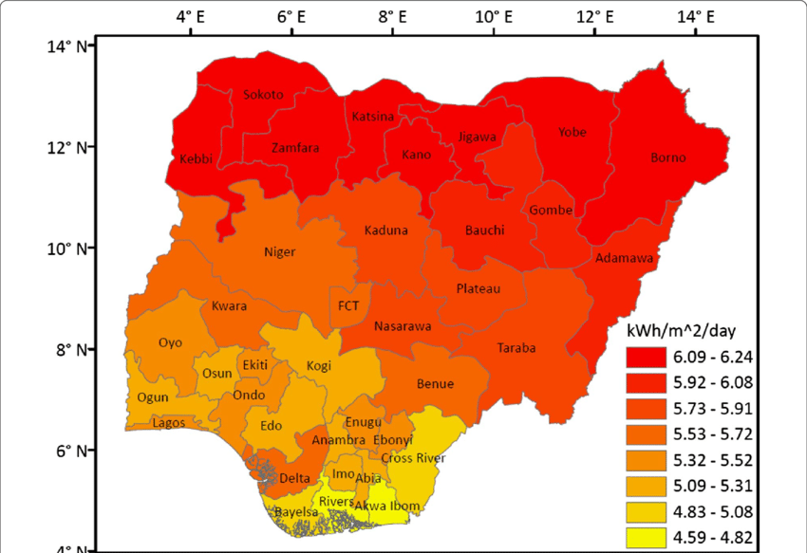
Fig 1.1: Map of Nigeria Indicating the global solar radiation
To achieve this, a comprehensive methodology is adopted. First, data collection is carried out, involving the acquisition of high-resolution solar radiation data, digital maps of building footprints, tree cover, and roof surface areas. These datasets are critical for understanding shading effects, roof orientations, and available space for solar installations. Next, a GIS-based spatial analysis and mapping process is employed using software like ArcGIS or QGIS. This step involves georeferencing, raster and vector analysis, and overlay techniques to identify and visualize areas with high solar exposure and minimal obstruction. Tools like hill shade, aspect, slope, and solar radiation modeling are used to process and interpret spatial data. Finally, a Solar Energy Potential Index (SEPI) is developed to rank different zones within FUTO based on their suitability for solar harvesting. The SEPI integrates multiple criteria; solar insolation, roof area, slope, aspect, and shading; using a multi-criteria decision analysis (MCDA) model. This enables the generation of a thematic map that supports data-driven decisions for solar infrastructure planning and deployment.

  - PROBLEM STATEMENT
Despite the abundance of solar energy in Nigeria, particularly in the southeastern region where the Federal University of Technology, Owerri (FUTO) is located, the institution still relies heavily on erratic grid electricity and costly fossil fuel-based generators for its power supply. This not only limits academic and research activities due to frequent power outages but also contributes to increased operational costs and environmental degradation. While solar energy offers a viable and sustainable alternative, its adoption at scale is hindered by a lack of accurate, location-specific data on solar energy potential across the campus.
Conventional methods of solar site assessment are often generalized and do not account for the spatial variations in building structures, roof orientations, shading from trees, and localized solar radiation levels within FUTO. As a result, decision-makers lack the technical insight required to identify the most suitable areas for solar panel deployment. There is therefore a critical need for a systematic and spatially informed approach to assess and visualize solar energy potential across the university environment. This project addresses that gap by employing a GIS-based methodology to evaluate and map the solar energy potential within FUTO, thereby providing a data-driven foundation for future investments in solar infrastructure.

  - AIMS AND OBJECTIVES
    - MAIN OBJECTIVE
To assess the solar energy potential within the Federal University of Technology, Owerri (FUTO) using Geographic Information System (GIS) technology in order to support sustainable energy planning and optimize solar power installations.
    - SPECIFIC OBJECTIVE
- To assess the solar energy potential in FUTO using GIS-based spatial analysis.
- To investigate the impact of spatial and environmental factors; such as building orientation, roof area, slope, aspect, and tree cover, on solar energy generation potential.
- To identify and map optimal locations within the FUTO campus for the installation of solar energy systems.
- To collect and integrate spatial data relevant to solar energy assessment, including solar radiation levels, building footprints, tree cover, and roof surface areas.*
- To apply GIS tools for mapping and analyzing solar exposure across different sections of the campus.
- To develop a Solar Energy Potential Index (SEPI) by incorporating multiple geospatial criteria through a weighted overlay model.
- To generate a thematic map that highlights high, moderate, and low solar energy potential zones within FUTO.*
- To provide recommendations for solar panel deployment based on the SEPI analysis and GIS outputs.*
- To contribute a replicable GIS-based methodology for institutional-scale solar energy planning in similar environments.*

  - SIGNIFICANCE OF STUDY
This study holds significant value in advancing the sustainable energy agenda of the Federal University of Technology, Owerri (FUTO) and similar institutions. By leveraging GIS technology to assess solar energy potential across the campus, the research provides a scientific basis for data-driven decisions in renewable energy planning. The identification of optimal locations for solar power installations will enable more efficient use of available infrastructure, such as rooftops and open spaces, while minimizing environmental and spatial constraints like shading and unsuitable roof orientations.
Importantly, the study directly contributes to FUTO's broader sustainability goals, offering a pathway for reducing dependence on fossil fuels and mitigating the institution’s carbon footprint. It supports the global transition to clean energy by promoting the integration of solar power into the university's energy mix—an essential step toward achieving energy self-sufficiency, cost savings, and environmental responsibility.
Beyond the immediate benefits to FUTO, the methodology and findings of this research can serve as a model for other universities and public institutions across Nigeria and sub-Saharan Africa, where reliable energy access remains a major challenge. By demonstrating how GIS-based analysis can streamline the planning and deployment of solar energy systems, the study reinforces the importance of spatial intelligence in sustainable development initiatives.

1.5 SCOPE OF STUDY
This study is limited to the assessment of solar energy potential within the geographical boundaries of the Federal University of Technology, Owerri (FUTO), Imo State, Nigeria. The research specifically focuses on evaluating spatial and environmental factors that influence the feasibility of solar power generation across the university campus. These include parameters such as solar radiation intensity, building footprints, roof surface areas, tree cover, slope, and aspect; all of which are crucial in determining solar panel efficiency and placement.
The analysis is conducted using Geographic Information System (GIS) tools, which enable the collection, processing, and interpretation of spatial data. The study employs a Solar Energy Potential Index (SEPI) to classify and rank different zones within FUTO based on their suitability for solar energy installations.
It is important to note that the scope does not include technical design or installation of solar panels, economic feasibility studies, or assessments of other renewable energy sources such as wind or hydro. Instead, the focus remains strictly on spatial analysis for solar energy planning, providing a foundational framework that can inform future solar infrastructure development in FUTO and similar academic institutions.

CHAPTER 2
LITERATURE REVIEW
2.1 INTRODUCTION
The increasing global demand for energy, coupled with the environmental impacts of fossil fuel consumption, has accelerated the transition toward renewable energy sources. Among renewables, solar energy has emerged as one of the most viable alternatives due to its abundance, scalability, and environmental sustainability. Solar power is particularly attractive in regions such as Sub-Saharan Africa, where high levels of solar irradiance remain underutilized [1]. Accurate mapping and assessment of solar resources are therefore critical to harnessing this potential effectively.
Geographic Information Systems (GIS) play an essential role in this context. GIS enables the integration of spatial data such as solar radiation, topography, land use, and infrastructure to identify suitable sites for solar energy systems [2]. With its ability to combine diverse datasets and perform multi-criteria evaluations, GIS provides an analytical framework for solar resource assessment and planning.
Nigeria, despite being richly endowed with solar resources, continues to experience persistent power shortages. Average daily solar insolation in the country ranges from 4.0 to 7.0 kWh/m²/day, with higher values in the northern regions [3]. However, the exploitation of this abundant energy source remains limited. While national and regional studies on solar energy potential exist, fewer works have focused on smaller, localized areas such as university campuses. For institutions such as the Federal University of Technology, Owerri (FUTO), which depend heavily on grid power and fossil fuel generators, solar energy mapping could provide a pathway toward energy sustainability. This literature review examines existing works on GIS-based solar energy potential mapping globally, in Africa, and in Nigeria, while identifying research gaps and highlighting the relevance of a campus-level study at FUTO.

2.2 GIS IN SOLAR ENERGY POTENTIAL MAPPING
Globally, GIS has been widely adopted for solar energy studies because of its capacity to handle spatial datasets and perform geospatial analysis. According to Choi et al. [4], GIS-based solar studies can be broadly categorized into three groups: solar radiation mapping, site evaluation, and potential assessment.
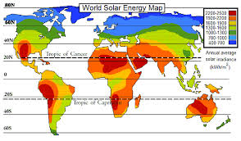
Fig 2.1: World Solar Energy Map

One of the earliest applications of GIS in solar mapping was the integration of solar radiation models such as the r.sun module in GRASS GIS. This tool computes direct, diffuse, and global irradiation based on digital elevation models (DEMs), atmospheric conditions, and solar geometry [5]. Such models have been used to estimate photovoltaic (PV) yield across different landscapes, accounting for slope, aspect, and shadowing effects. Similarly, commercial GIS platforms such as ArcGIS have developed solar analyst tools capable of estimating solar radiation over specified time periods [6].
On a global scale, datasets such as the Global Solar Atlas, developed by the World Bank and Solargis, provide high-resolution solar resource maps at ~250 m resolution. These datasets offer parameters such as global horizontal irradiation (GHI), direct normal irradiation (DNI), and PV output estimates, which are essential for feasibility studies [7]. The availability of such global data has supported renewable energy planning, especially in data-scarce regions.
GIS has also been used for large-scale renewable energy zoning. For example, Sanchez-Lopez et al. [8] employed GIS and remote sensing data to identify optimal solar power plant sites in Spain, considering environmental and infrastructural constraints. Similarly, Charabi and Gastli [9] applied GIS for solar farm siting in Oman, integrating solar radiation, slope, land cover, and grid connectivity layers. These global applications demonstrate the versatility of GIS in both micro-scale and macro-scale solar resource assessments.

2.3 MULTI CRITERIA AND ADVANCED GIS TECHNIQUES
Beyond simple radiation mapping, advanced GIS approaches employ multi-criteria decision analysis (MCDA) to evaluate solar suitability. This involves integrating multiple spatial layers such as solar radiation, slope, land use, distance to roads, and grid infrastructure, each weighted according to its importance. The Analytic Hierarchy Process (AHP) is a commonly used weighting method [10].
In Saudi Arabia, Bayounis and Eldamaty [11] used AHP within GIS to evaluate rooftop solar suitability in Makkah city. Their study found that nearly 80% of the urban area was highly suitable for PV installations. Similarly, a study in Northwestern Nigeria applied multi-criteria evaluation to identify optimal sites for solar PV farms, considering irradiation, slope, land cover, and infrastructure [12]. These works highlight the effectiveness of MCDA in balancing technical, environmental, and socio-economic factors.
Recent studies have also integrated 3D GIS and LiDAR data for rooftop solar assessment. Idrovo-Macancela et al. [13] used LiDAR-derived building footprints to estimate rooftop solar potential, demonstrating the accuracy of 3D shadow modeling. In São Paulo, Brazil, Rizcanofana [14] combined LiDAR data with the r.sun model to estimate annual PV yield and rooftop suitability, providing outputs such as energy yield, CO₂ reduction, and cost savings. Such 3D GIS approaches are particularly relevant in urban settings where shading from buildings significantly affects solar performance.

2.4 SOLAR POTENTIAL STUDIES IN AFRICA AND NIGERIA
Africa is one of the most solar-rich continents, receiving an average of 2000–2500 kWh/m²/year of solar radiation. Several GIS-based studies have been conducted to identify solar hotspots across the continent. A recent study by Mahmoud et al. [15] employed clustering techniques with GHI and DNI datasets to identify high-potential solar zones in Algeria, Egypt, Nigeria, and South Africa. These findings emphasize the immense opportunities for solar deployment in Africa.
In Nigeria, GIS-based solar assessments have gained increasing attention. Okedu et al. [16] conducted a national GIS-based assessment of renewable energy resources, combining spatial interpolation techniques with irradiation, topography, and infrastructure data. Their results indicated high solar potential across the country, particularly in the north. Similarly, Salihu et al. [17] applied ArcGIS to satellite-derived radiation datasets to assess solar energy potential in Northern Nigeria. Their findings confirmed the suitability of the region for large-scale PV projects.
Review papers have also synthesized solar energy studies in Nigeria. Agbo et al. [18] highlighted the status of solar energy deployment in Nigeria, noting that while the country’s solar potential exceeds 400,000 MW, actual installed capacity remains below 50 MW due to infrastructural, financial, and policy barriers. Ebhota and Inambao [19] emphasized the role of GIS in bridging this gap by providing spatial insights for policy and investment decisions.
Despite these advances, most Nigerian studies have focused on broad regional or national scales. Few works have examined micro-level applications, such as solar potential mapping within specific institutions, campuses, or communities. This represents a significant research gap.

2.5 RESEARCH GAPS AND RELEVANCE TO FUTO
The reviewed literature shows that GIS has been successfully applied at global, national, and regional levels for solar energy potential assessment. However, there remains a shortage of localized, campus-level studies in Nigeria. For institutions like FUTO, such localized analysis is particularly relevant.
A campus-level solar potential map would:
- Provide insights into rooftop suitability for PV installations.
- Identify open land areas suitable for ground-mounted solar systems.
- Support the university’s transition toward energy independence and cost savings.
- Serve as a case study that can be replicated across other Nigerian universities and communities.
By integrating DEM analysis, solar radiation models, and multi-criteria evaluation within a GIS framework, this study will generate detailed spatial outputs that inform energy planning at FUTO. Such an approach addresses the current literature gap and contributes to Nigeria’s broader renewable energy development.

2.6 CONCLUSION
GIS has proven to be an indispensable tool in solar energy potential assessment, enabling spatial integration of solar, topographic, infrastructural, and environmental datasets. Globally, GIS has been applied to large-scale solar farm siting, rooftop solar assessment, and resource mapping using tools such as r.sun and datasets like the Global Solar Atlas. In Africa and Nigeria, studies have confirmed the continent’s vast solar resources, but the majority of these works focus on macro-scale analyses.
This review identifies a gap in campus-scale studies, particularly within Nigerian institutions. The proposed GIS-based solar energy potential mapping at FUTO will therefore fill an important niche by providing localized, actionable insights into solar deployment. Such a study not only contributes academically but also has practical implications for sustainable energy development in Nigeria.

CHAPTER 3
MATERIALS AND METHODS
3.1 STUDY AREA
The study was conducted within the Federal University of Technology, Owerri (FUTO), located in Owerri West Local Government Area of Imo State, Nigeria. The campus covers approximately 40km² and lies between latitude 5.387°N and longitude 7.030°E. FUTO is situated in the humid tropical climatic region with average annual solar radiation of about 4.61 kWh/m²/day. The campus comprises academic buildings, administrative complexes, residential quarters, and open spaces, which collectively provide a diverse range of rooftops and land surfaces suitable for solar energy exploration [1].

3.2 MATERIALS
The materials used for this research include:
    - Software and Tools
- ArcGIS Pro 2021 (with Spatial Analyst extension) / QGIS 3.x (open-source alternative) [2]
- Microsoft Excel for attribute data processing
- Google Earth Pro for base imagery verification

3.2.2 Data Sources
- Satellite Imagery: Sentinel-2 or Landsat 8 imagery for land cover and tree canopy extraction [3], [4]
- Digital Elevation Model (DEM): SRTM (30m resolution) for slope and aspect analysis [5]
- Solar Radiation Data: NASA POWER database or Meteonorm for historical global horizontal irradiance (GHI) [6]
- Building Footprints: Digitized manually from high-resolution imagery [7]
- Tree Cover Data: Derived from Normalized Difference Vegetation Index (NDVI) classification [8]

3.3 METHODOLOGY
The methodology adopted integrates GIS-based spatial analysis, remote sensing techniques, and multi-criteria decision analysis to assess the solar energy potential of FUTO. The workflow is presented in sequential steps:

3.3.1 Data Collection and Preparation
- Acquisition of DEM, satellite imagery, and solar radiation data.
- Clipping of all spatial data layers to the FUTO boundary.
- Georeferencing and projection of datasets to UTM Zone 32N, WGS 84 datum.
- Digitization of building footprints and extraction of roof areas.
- Classification of land cover to identify vegetation/tree canopy zones.

3.3.2 Environmental and Spatial Factor Analysis
To investigate the effect of spatial and environmental variables on solar energy generation, the following analyses were performed:
- Roof Area Calculation: Building footprints were converted into polygons, and their areas computed using GIS tools [9].
- Building Orientation: Aspect values were extracted from DEM and assigned to building rooftops.
- Slope Analysis: DEM was processed to generate slope raster; rooftops with slopes ≤15° were considered suitable [10].
- Aspect Analysis: South-facing (135°–225°) and east-facing rooftops were prioritized due to higher solar exposure [11].
- Tree Cover and Shading: NDVI classification and proximity buffers were applied to determine shaded areas that could reduce solar efficiency [12].

3.3.3 Solar Radiation Analysis
The ArcGIS “Area Solar Radiation” tool (or QGIS solar radiation model) was used to calculate the global horizontal irradiance (GHI) across the campus. This process modeled the direct, diffuse, and reflected radiation considering topographic and atmospheric conditions [13].

3.3.4 Solar Energy Potential Index (SEPI) Development
A multi-criteria decision analysis (MCDA) approach was adopted to integrate the influencing factors. Weighted overlay analysis was carried out in GIS, where factors were assigned, weights based on their relative importance [14].

The weighted overlay produced a Solar Energy Potential Index (SEPI) raster, classified into three categories: High, Moderate, and Low Potential Zones.

Factor | Criterion | Weight (%)
Solar radiation | High GHI zones preferred | 35
Roof slope | ≤15° most suitable | 15
Aspect | South/East orientation preferred | 10
Roof area | Larger area preferred | 25
Land Cover | Stable and reflective surfaces score higher | 10
Access Distance | Shorter Distance is better | 5

Table 3.1: Criteria and Weights for SEPI Development

3.3.5 Thematic Map Generation
The SEPI output was reclassified and symbolized into three classes (high, moderate, low). A thematic map of solar energy potential across FUTO was produced, highlighting optimal locations for solar energy deployment [15].

3.3.6 Validation and Accuracy Assessment
- Model results were compared with solar radiation data from meteorological sources (NASA POWER / weather stations).
- Ground truthing was conducted using GPS points and field observations to confirm rooftop orientations, shading conditions, and land use classes [16].
CHAPTER FOUR
RESULTS AND DISCUSSIONS
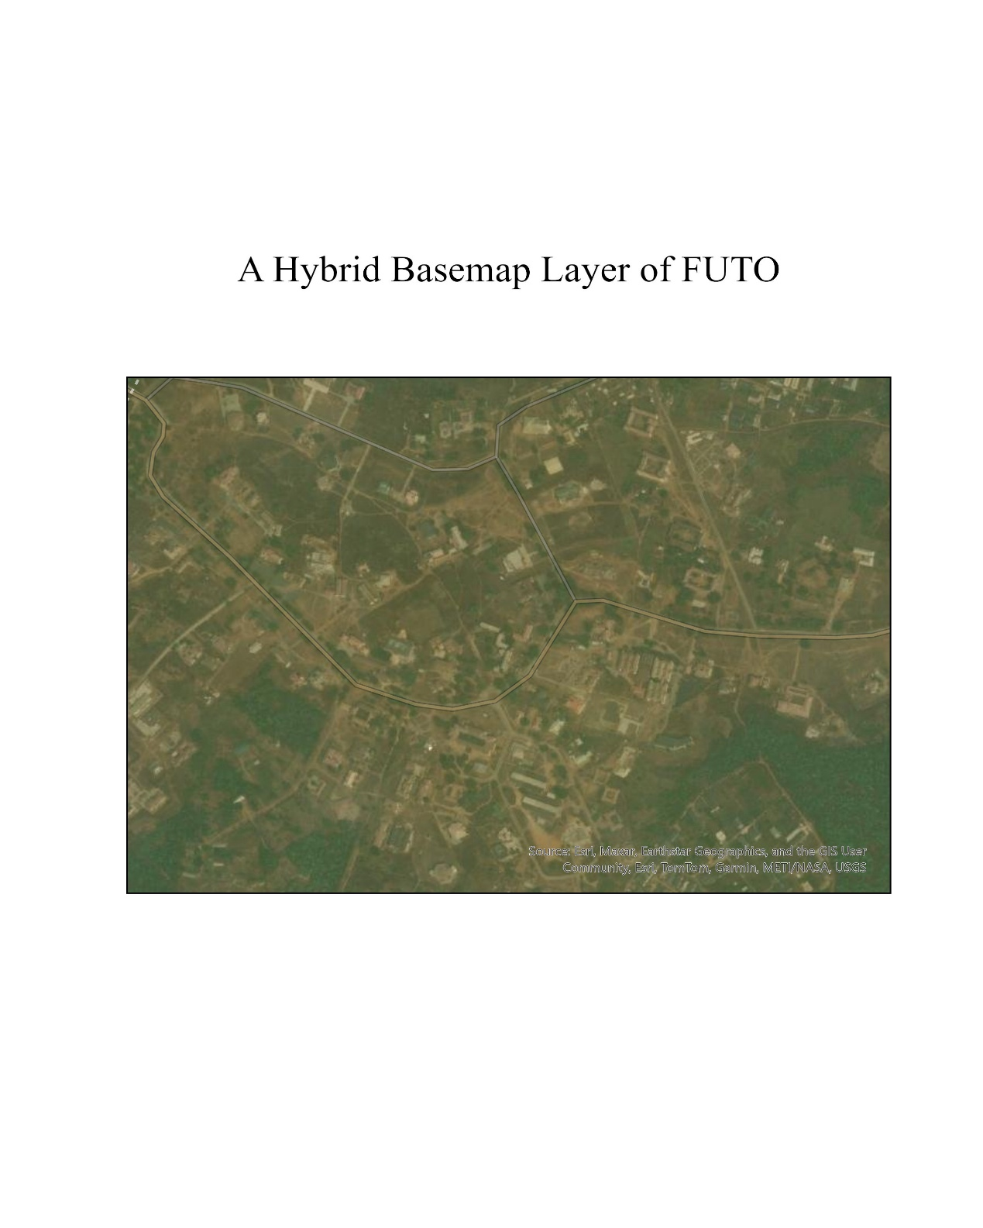

Fig 4.1: A hybrid Basemap of FUTO obtained from ARCGIS

4.1 IMPACT OF SPATIAL AND ENVIRONMENTAL FACTORS ON SOLAR ENERGY POTENTIAL
The potential for solar energy generation on building rooftops is strongly affected by spatial and environmental factors such as building orientation, roof area, slope, aspect, and tree cover.
- Building orientation determines the amount of solar radiation received on a surface. In the Northern Hemisphere, south-facing roofs generally achieve maximum annual insolation. Studies have shown that correct orientation can significantly reduce energy demand and improve PV output [1], [2].
- Roof area defines the maximum space available for PV installation. Larger and less obstructed roof surfaces allow for more modules and higher capacity, while complex or shaded roofs reduce effective usable area [3].
- Slope (tilt) influences the incidence angle of sunlight. Roofs with slopes close to the site’s optimal tilt maximize annual irradiance, while steep or shallow slopes reduce efficiency [4].
- Aspect refers to the compass direction of the slope. Roofs with aspects toward the equator (south in Nigeria) typically receive the most solar energy annually, while east/west-facing roofs capture more morning/afternoon sun but less overall radiation [5].
- Tree cover and shading significantly reduce available solar energy. Even partial shading can lower PV performance due to series connection effects. Studies highlight the importance of vegetation mapping when estimating rooftop solar potential [3], [6].
In summary, orientation and aspect largely govern solar exposure, slope determines the incidence of rays, roof area sets the scale of installation, and shading limits usable capacity. Integrating these factors into GIS-based solar mapping provides a realistic estimate of rooftop PV potential for locations such as FUTO.
4.2 GIS ANALYSIS OF SOLAR RADIATION IN FUTO
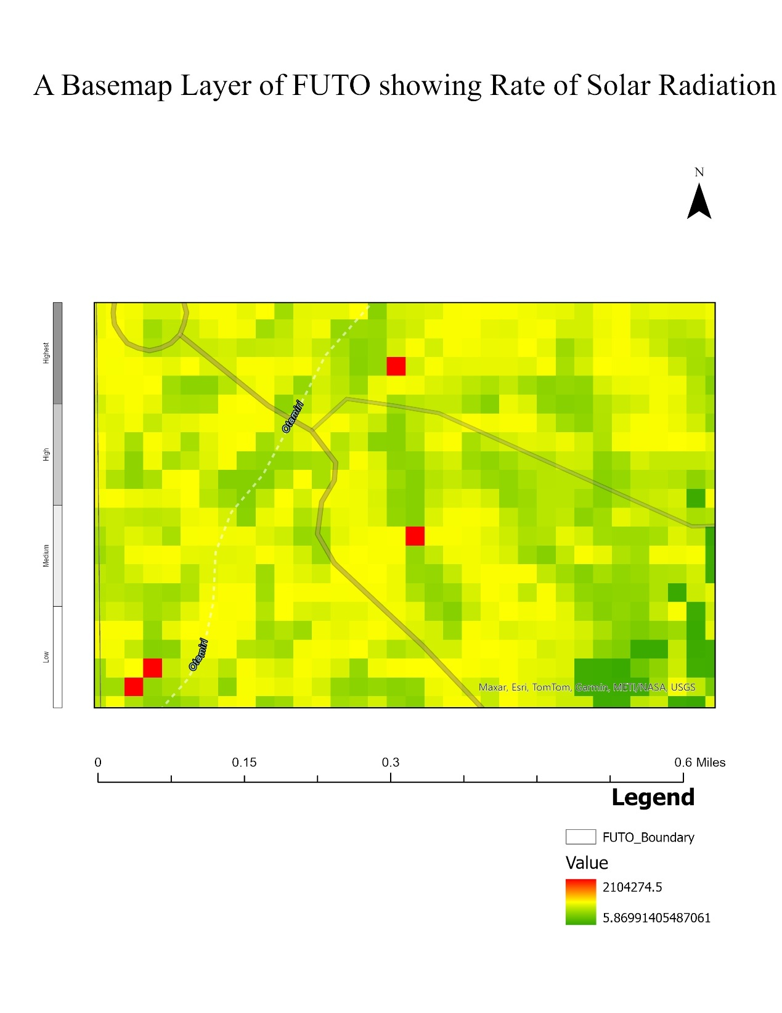
Fig 4.2: A hybrid Basemap of FUTO showing amount of solar radiation.

From the above Basemap, decent amount of solar radiation can be found anywhere within FUTO. But the places marked red have the highest amount of solar radiation. Upon comparison with the basemap, the four points are identified. They are:
- Vast Bushland across Otammiri Bridge
- A small wasteland beside Otammiri River, Behind SMAT
- By SOHT and Department of Public Health Technology.
(manually visit, take pictures and comment on feasibility using spatial features)

4.3 DEVELOPMENT OF A SOLAR ENERGY POTENTIAL INDEX (SEPI)
The Solar Energy Potential Index (SEPI) for the Federal University of Technology, Owerri (FUTO) was developed to evaluate the relative suitability of selected building rooftops for solar photovoltaic (PV) installation. The process involved integrating multiple geospatial and non-spatial criteria into a composite model using a weighted overlay approach. Each criterion was assigned a weight based on its relative importance to solar energy generation, and standardized scores were computed to derive the SEPI value for each location.

4.3.1 Criteria Selection
Six major criteria were considered in developing the SEPI for FUTO:
- Solar Radiation (kWh/m²): Represents the total annual solar irradiance incident on the roof surface. Higher radiation implies higher solar potential.
- Roof Area (m²): Determines the available space for panel installation and influences total energy yield.
- Slope (°): Indicates roof inclination. Moderately sloped roofs (5–15°) are ideal, as very steep slopes reduce effective solar capture.
- Aspect (°): Describes the direction a roof faces, measured clockwise from north (0°). South-facing roofs (≈180°) are most suitable in the Northern Hemisphere.
- Land Cover Type: Reflects the surface characteristics of the roof (e.g., concrete, metal, vegetation). Non-reflective and stable surfaces are more favorable.
- Access Distance (m): The distance to existing access routes or service points. Shorter distances reduce installation and maintenance costs.

4.3.2 Data Acquisition and Preparation
Data for the selected buildings were obtained from Google Earth Pro and Global Solar Atlas.
- Annual solar radiation values were derived from Global Solar Atlas (in kWh/m²).
- Roof areas and distances were measured using Google Earth Map.
- Roof slope and aspect were estimated by visual inspection and bearing measurement in degrees.
- Land cover type was identified visually (e.g., concrete roofs for most academic and administrative buildings).
The study focused on four representative buildings:

- School of Electrical Systems and Engineering Technology (SESET) Building
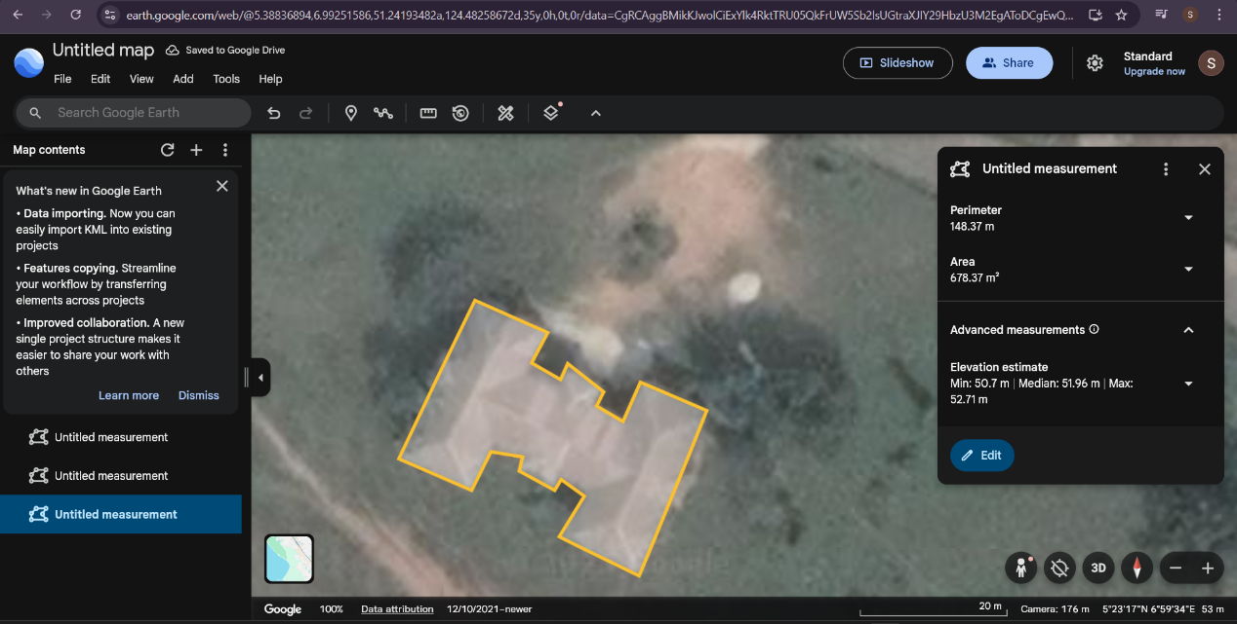

Fig 4.3: Google Earth Mapping roof measurement of SESET
- Hostel A
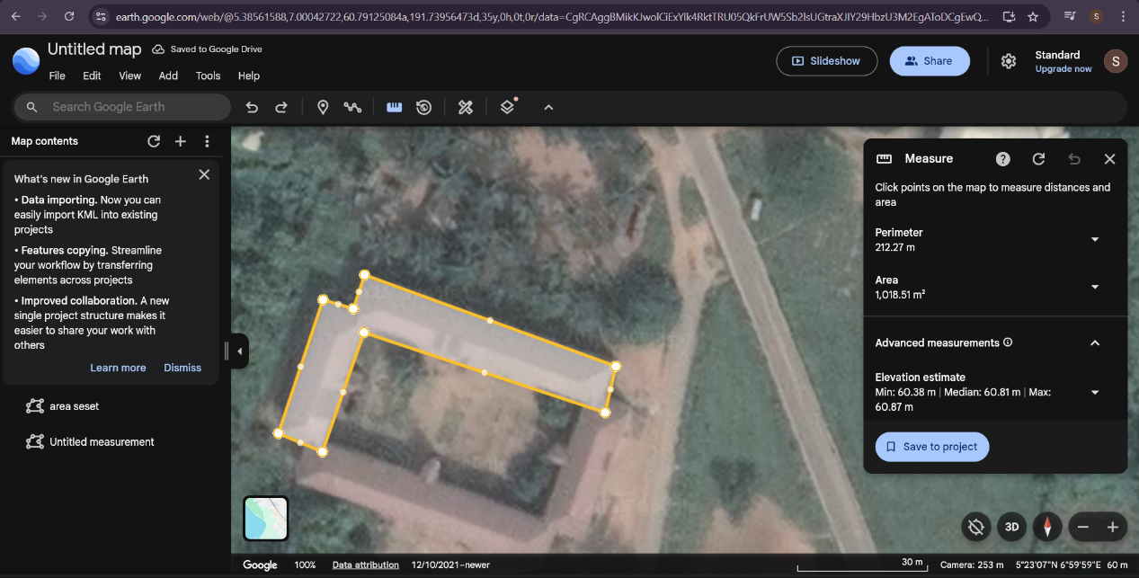

Fig 4.4: Google Earth Mapping roof measurement of Hostel A

- University Library
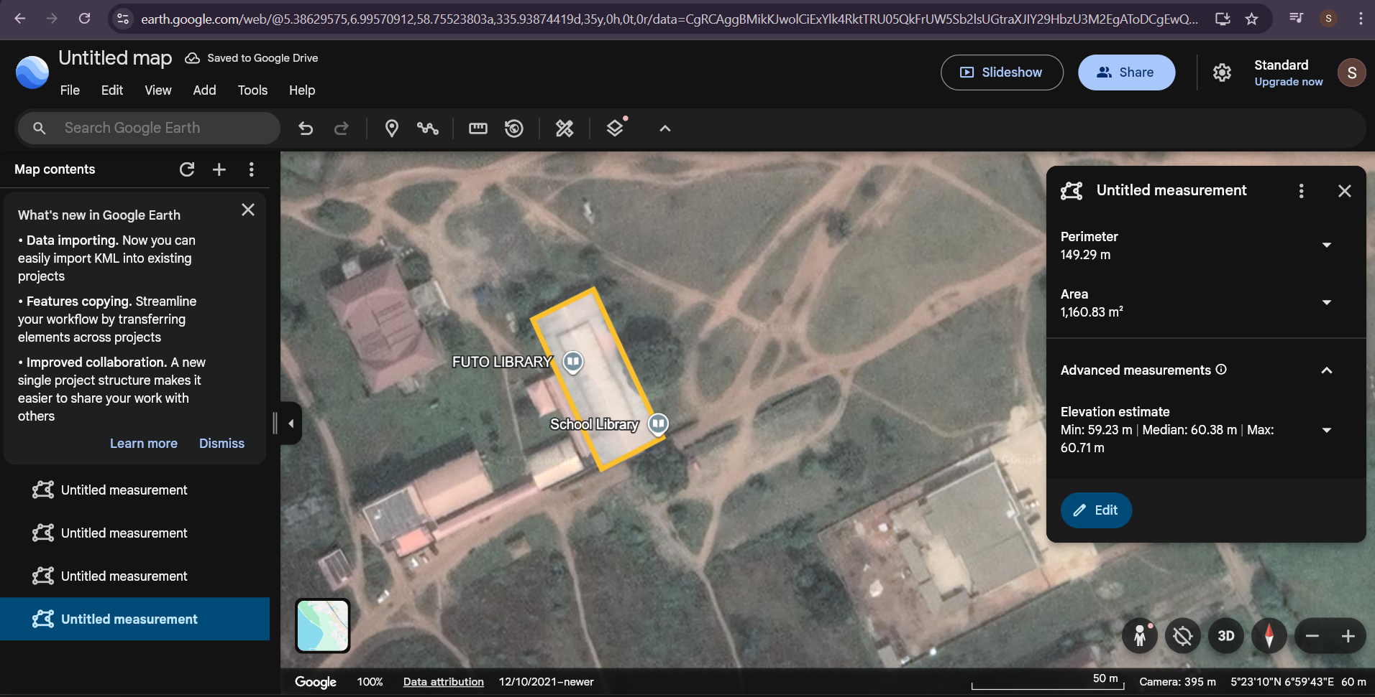

Fig 4.5: Google Earth Mapping roof measurement of University Library
- ICT Centre
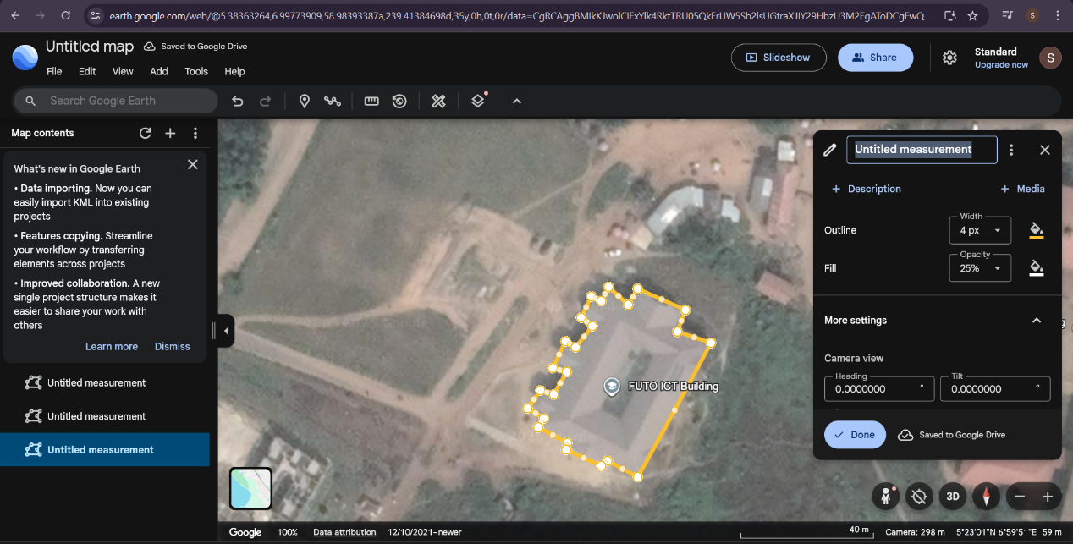

Fig 4.6: Google Earth Mapping roof measurement of ICT Centre (outward)
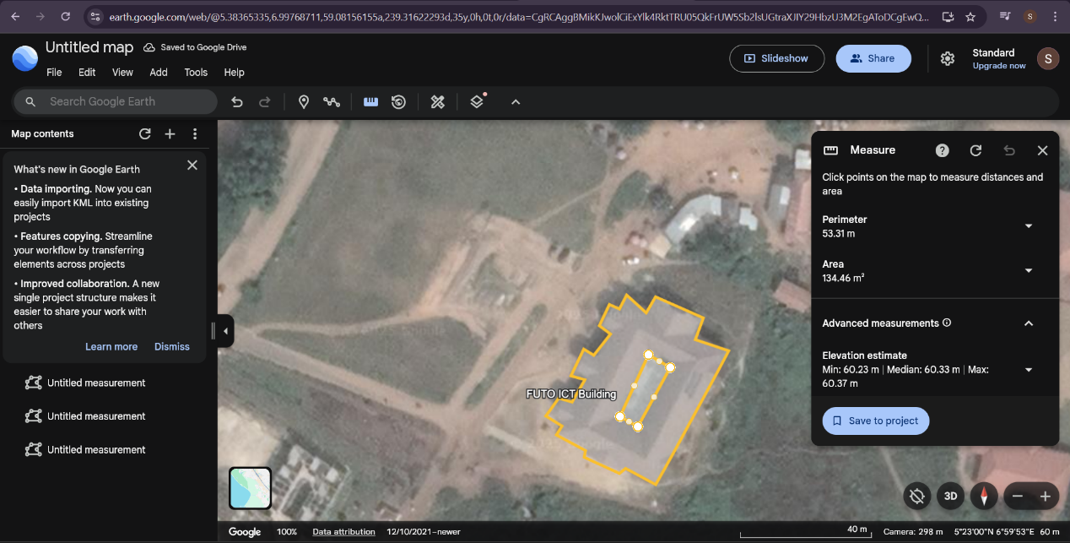

Fig 4.7: Google Earth Mapping roof measurement of ICT Centre (Inward)
Note that the roof area for ICT is gotten by subtracting the inward from the outward area, while that of Hostel A is multiplied by 2 to get the area.
All data were compiled into a structured database using Microsoft Excel, where the SEPI model was implemented.

4.3.3 Criteria Scoring and Standardization
Each criterion was normalized to a 10-point scale to ensure comparability. Scoring was based on the relative suitability of each parameter to solar power generation. The ranges and corresponding scores are shown below:

Criterion | Parameter Range | Score Description
Solar Radiation(kWh/m²) | ≥1800 → 10; 1750–1799 → 8; 1700–1749 → 6; 1650–1699 → 4; <1650 → 2 | Higher radiation → higher score
Roof Area (m²) | ≥500 → 10; 400–499 → 8; 300–399 → 6; 200–299 → 4; <200 → 2 | Larger roofs are more suitable
Slope (°) | 5–15° → 10; 0–4° → 8; 16–25° → 6; >25° → 4 | Moderate slopes are optimal
Aspect (°) | 180° (South) → 10; 135°/225° (SE/SW) → 8; 90°/270° (E/W) → 6; Others → 4 | South-facing roofs preferred
Land Cover Type | Concrete → 10; Metal → 8; Vegetation/Other → 4 | Stable and reflective surfaces score higher
Access Distance (m) | 0–30 → 10; 31–50 → 8; 51–70 → 6; 71–100 → 4; >100 → 2 | Shorter access distance is better

Table 4.1: Criteria Scoring and Standardization
Each score was automatically generated in Excel using logical formulas, ensuring consistency across all datasets.

4.3.4 Weight Assignment and Weighted Overlay Model
Weights were assigned to each criterion according to its significance in determining solar potential. The weights sum to unity (1.0) as shown below:
Criterion | Weight
Solar Radiation | 0.35
Roof Area | 0.25
Slope | 0.15
Aspect | 0.10
Land Cover | 0.10
Access Distance | 0.05

Table 4.2 Weight Assignments to criterions

The Solar Energy Potential Index (SEPI) was computed for each building using the weighted linear combination model:

$$SEPI = \left(0.35 × S_{solar}\right)+ \left(0.25 × S_{area}\right)+ \left(0.15 × S_{slope}\right)+ \left(0.10 × S_{aspect}\right)+ \left(0.10 × S_{landcover}\right)+ \left(0.05 × S_{access}\right)$$
where $S_{\left\{solar\right\}}, S_{\left\{area\right\}}, S_{\left\{slope\right\}}, S_{\left\{aspect\right\}}, S_{\left\{landcover\right\}}, S_{\left\{access\right\}}$ are the standardized scores (0–10 scale) of each criterion.

4.3.5 Computation and Classification
The SEPI model was implemented in Microsoft Excel, where formula-based automation ensured dynamic computation of each building’s index value. The results were categorized into three suitability classes:

SEPI Range | Suitability Class
8.0 – 10.0 | High
6.0 – 7.9 | Moderate
< 6.0 | Low

Table 4.3 SEPI range Classification

4.3.6 Results and Interpretation
The computed SEPI values for the four buildings are summarized below


Fig 4.8: Excel sheet showing SEPI calculation for FUTO

From the analysis, the Library, ICT Centre and SESET Building recorded the highest SEPI values, indicating excellent suitability for rooftop solar PV installation. Hostel A falls within the moderate suitability range, suggesting it can still support solar installations with minor adjustments or orientation optimization.

4.4 RECOMMENDATIONS FOR SOLAR PANEL DEPLOYMENT BASED ON THE SEPI ANALYSIS
The primary output of this study is the Solar Energy Potential Index (SEPI) value that classifies the Federal University of Technology, Owerri (FUTO) campus into zones of high, moderate, and low suitability for solar energy generation. This classification was derived from a weighted overlay analysis of key geospatial and environmental factors: solar radiation (35%), roof slope (15%), aspect (10%), roof area (25%), access distance (5%) and land cover (10%) based on Table 3.1.
This section provides actionable recommendations for the deployment of solar photovoltaic (PV) systems based on the SEPI results. The objective is to translate the spatial analysis into a strategic implementation plan that optimizes energy yield, maximizes return on investment, and aligns with FUTO's sustainability goals. The recommendations will focus on selecting the most appropriate solar panel technology; specifically monocrystalline, polycrystalline, or thin-film, for each potential zone, thereby creating a robust framework for the university's transition to renewable energy.

4.4.1 Interpretation of SEPI Zones
The SEPI values categorizes the FUTO campus into three distinct zones, each defined by a unique combination of the weighted criteria. Understanding the characteristics of these zones is fundamental to tailoring technology selection and deployment strategies.
1)High Potential Zones: These locations represent the most favorable areas for solar PV installation. They are characterized by high annual solar radiation, optimal roof orientation (south or east-facing), gentle slopes (≤15 °), large, unobstructed roof areas, and minimal to no shading from surrounding trees or buildings. These prime locations are expected to yield the highest possible energy output and should be prioritized for immediate development to power critical university infrastructure.
2) Moderate Potential Zones: These areas offer viable, but not optimal, conditions for solar energy generation. They may exhibit one or more limiting factors, such as partial shading during certain hours, a less-than-ideal aspect (e.g., west-facing), or slightly constrained roof space. While the energy yield will be lower than in high-potential zones, these locations are still economically and technically feasible for solar deployment, particularly for supplementary power needs.
3). Low Potential Zones: These locations are the least suitable for solar PV installations. They are typically characterized by significant shading, poor orientation (north-facing), steep roof slopes, or very limited surface area. Deploying conventional solar panels in these zones would likely result in a poor return on investment due to low efficiency and energy output. However, specialized technologies might be considered in specific niche applications.

4.4.2 Analysis of Solar Panel Technologies
The choice of solar panel technology is a critical decision that impacts project cost, efficiency, land/roof usage, and long-term performance. The three technologies considered for FUTO are monocrystalline, polycrystalline, and thin-film panels.

4.4.3 Deployment Recommendations per SEPI Zone
Based on the synergy between the characteristics of the SEPI zones and the different panel technologies, the following deployment strategy is recommended for FUTO.

A. High Potential Zones: Prioritize Monocrystalline Panels
For rooftops and open spaces identified as High Potential, the primary recommendation is the deployment of high-efficiency monocrystalline solar panels.

Justification:
These zones are FUTO's most valuable solar assets. Using monocrystalline panels ensures that the maximum possible energy is harvested from these premium locations. Their superior space efficiency means more installed capacity on limited rooftop areas, and their excellent performance in high temperatures makes them perfectly suited for the Owerri climate [9].

Target Buildings:
- Administrative Buildings: Such as the Senate Building and Registry, which have large, flat, or gently sloped roofs and high daytime energy demand.
- Major Lecture Theaters and Halls: Like the Hall of Mercy (1000 Capacity), which require consistent power for lighting, sound systems, and cooling.
- Laboratories and Research Centers: In schools like SEET and SAAT, where uninterrupted power is critical for experiments and equipment.

Implementation Strategy:
These locations should be targeted in the first phase of FUTO's solar energy rollout to guarantee immediate and significant reductions in electricity costs and reliance on generators.

B. Moderate Potential Zones: Deploy Polycrystalline Panels
For areas classified as Moderate Potential, the most suitable choice is polycrystalline solar panels.

Justification:
These locations can still contribute significantly to FUTO's energy portfolio, but the conditions do not justify the premium cost of monocrystalline panels. Polycrystalline panels offer a cost-effective solution, providing a solid return on investment without requiring perfect conditions [8]. The slightly lower efficiency can be compensated for if sufficient roof area is available.

Target Buildings:
- Student Hostels: Which have large, repetitive roof structures and consistent, albeit lower-intensity, energy needs.
- Staff Quarters and Residential Buildings: Where cost-effectiveness is a key consideration for widespread adoption.
- Departmental Buildings and Libraries: With less-than-ideal orientation or minor shading issues.

Implementation Strategy:
Deployment in these zones should constitute the second phase of the project, expanding the university's solar capacity after the highest-yielding sites are operational.

C. Low Potential Zones: Niche Applications or Avoidance. Deploying solar panels in Low Potential Zones requires careful consideration. For most of these areas, conventional PV installation is not recommended due to poor financial and technical viability [10].

Justification:
The combination of heavy shading, poor orientation, and limited space would severely hamper the performance of any solar panel, leading to an unacceptably long payback period.

Potential Niche Applications:
- Thin-Film Panels: In specific cases where a building in this zone has a large, curved, or structurally weak roof, lightweight and flexible thin-film panels could be considered [11]. Their better performance in shaded conditions makes them the only viable option, but a detailed cost-benefit analysis is essential.
- Solar Street Lighting: Standalone solar-powered streetlights can be installed in open spaces within these zones, as their individual small panels can be oriented optimally, independent of building rooftops.

4.4.4 Implementation Strategy
These areas should be assigned the lowest priority. Investment should only be considered after the high and moderate potential zones have been fully exploited, and only for specialized applications where thin-film technology offers a clear advantage. To ensure a successful transition, the deployment should be guided by a structured framework:

- PHASE 1 - CRITICAL INFRASTRUCTURE (HIGH POTENTIAL ZONES): The Focus is on deploying monocrystalline panels on administrative buildings, major lecture halls, and research labs. The goal is to power essential services, achieve significant cost savings, and build institutional confidence in solar technology.

- PHASE 2 - CAMPUS-WIDE EXPANSION (MODERATE POTENTIAL ZONES): Here cost-effective polycrystalline panels are used to solarize student hostels, staff quarters, and other departmental buildings. This phase aims to broaden the impact of solar energy across the campus community.

- PHASE 3 - SPECIALIZED SOLUTIONS (LOW POTENTIAL ZONES): An Evaluation of niche opportunities for thin-film panels or standalone systems in low-potential areas is performed, ensuring each project is independently justified.

It is recommended that the installations be designed as grid-tied hybrid systems. This allows FUTO to draw power from the grid when solar generation is insufficient (e.g., at night) and potentially feed excess power back into the grid. Battery storage should be included for critical loads to ensure uninterrupted power supply.

